Lesson Notes

1. What is the main purpose of an Operating System?

• Simpler/more efficient application programs

• Consistent User Experience

• Allow Multiple Applications Running At Same Time

2. What is the difference between Operating System Software and Use Application Software?

• Hardware Independence

• User Interface

• Resource Allocation

3. What is the difference between Operating System Software and Computer Hardware?

• An operating system (OS) is the software that manages computer hardware and software resources and provides common services for computer programs and enables users to interact with the hardware. ... Application software refers to all applications collectively.

4. What are the main parts of an Operating System?

• Graphical User Interface (GUI)

• Windows Display, mouse, keyboard, sound, etc.

• System Calls

• Device Drivers

• I/O Manager

• Memory Manager

• Process Manager

• Security Monitor

5. What are some popular operating systems?

• Windows OS

• Mac OS

• Linux / Unix

• Android

• iOS

Reference Diagram

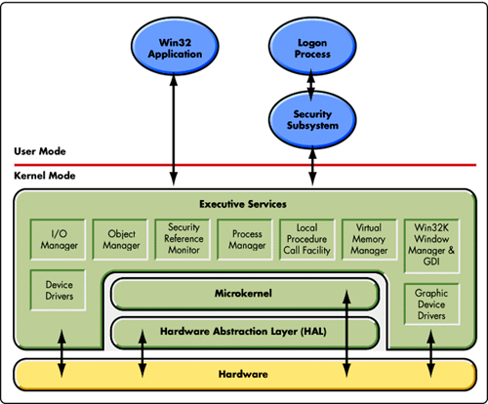

device driver graphic

(locally attached printer) device

driver

Student Questions

1. What is a device driver?

a. Provide a brief summary

• A device driver is a software program that controls a particular type of hardware device that is attached to a computer. When buying an operating system, many device drivers are built into the product.

b. List some devices that require a device driver.

• Typical devices are keyboards, printers, scanners, digital cameras and external storage devices. Each of these need a driver in order to work properly.

c. Provide a label on the reference diagram for the location of a device driver for your graphics card.

d. Provide a label on the reference diagram for the location of a device driver for a locally attached printer.

2. What is a DLL?

a. Provide a brief summary

• DLL files are nothing more than a means for developers to use shared code and data, allowing to upgrade functionalities without the need to re-link or re-compile applications. DLL files contain code and data that is used by several different applications.

b. Explain how DLLs are related to user application programs

• DLL files contain code and data that is used by several different applications.

c. Provide a label on the reference diagram for the location of a DLL

3. What is a windows manager?

a. Provide a brief summary

• A window manager is system software that controls the placement and appearance of windows within a windowing system in a graphical user interface. Most window managers are designed to help provide a desktop environment.

b. Explain how a windows manager is related to user application programs

c. Provide a label on the reference diagram for the location of a DLL

4. What is the windows task manager?

a. Provide a brief summary

• Task Manager, previously known as Windows Task Manager, is a task manager, system monitor, and startup manager included with Microsoft Windows systems.

b. List and explain four (4) types of system information provided by the task manager

c. Provide a label on the reference diagram for the operating system components related to each type of information.